

Republic of the Philippines
University of Eastern Philippines
University Town, Northern Samar
Graduate Studies

Name: Shierna R. Gulariza
Course: MAME-II
Professor: Dr. Ronato S. Ballado
Subject: Math 835 Educational Technology
Year/Semester: 2018, Summer Semester
Topics: Technological, Pedagogical, and Content Knowledge (Implication for Teachers)

I. INTRODUCTION
This paper presents Technological, Pedagogical and Content Knowledge as framework for the integration of technology within teaching. Three main bodies of knowledge—technological knowledge, pedagogical knowledge and content knowledge-inform the design of this theoretical framework. Accordingly, we describe the characteristics of these three bodies of knowledge, along with the bodies of knowledge that emerge from the interactions between and among them. We believe that TPACK framework has significant implications for teachers and the teacher educators, specifically, we argue that teachers should be considered “designers” of curricula, and with regards to teacher educators, we identify “learning technology by design” and activity types as two key methods for the development of TPACK.

II. DISCUSSION
IMPLICATIONS FOR TEACHERS
1. A teacher should be an active agent and to become designers of their own curriculum. The complex and ill-structured nature of teaching with technology leads to the idea of “teachers as designers” who are constantly engaged in the active, iterative, and feedback-driven process of problem-finding and creative problem solving. Teachers often make creative decisions based on the teaching context, technology available, how this tools can enhance the teaching pedagogies-which are designed based on the unique affordances and limitations of the content at hand. During the process of designing their own curricula, the decisions that go into making up the curriculum become the primary responsibility of teachers, who understand the particularities of teaching contexts.
2. “Teachers as Designers”. Design or learning by design, requires learners to actively experience the process and they provide rich contexts for learning (kafai, 1996, Perkins, 1986).
3. Dozens of methods have been proposed for the development of TPACK, among various approaches, an emphasis upon how teachers integrate technology in their practice is more important than the emphasis upon what teachers integrate in their practice. For example, approaches that develop technological knowledge (TK) in isolation, where technology literacy is the goal, fail to assist teachers in the development of the educational use of this tools.
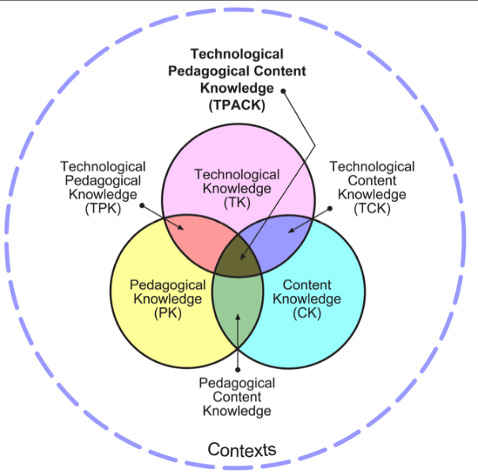
True technology integration is understanding and negotiating the relationships among Technology, Pedagogy and Content.
Teachers need to know not only the subject matter they teach, but also the manner in which the subject matter can be changed with the application of technology.

III. CONCLUSION
Technology education should become an integral part of teacher education, moving beyond teaching technology literacy in isolation. We need to think of which technology best supports the learning activities’ successful implementation. Teaching successfully with technology requires continually creating, maintaining, and reestablishing a dynamic equilibrium among all components: content, pedagogy, technology and teaching/learning contexts.

IV. REFERNCES
- Mishra, P., & Koehler, M. J. (2006). Technological pedagogical content knowledge: A new framework for teacher knowledge. Teachers College Record, 108(6), 1017-1054.
- Koehler, M. J. Technological Pedagogical Content Knowledge. www.TPACK.org

